Communication and Language (CL)
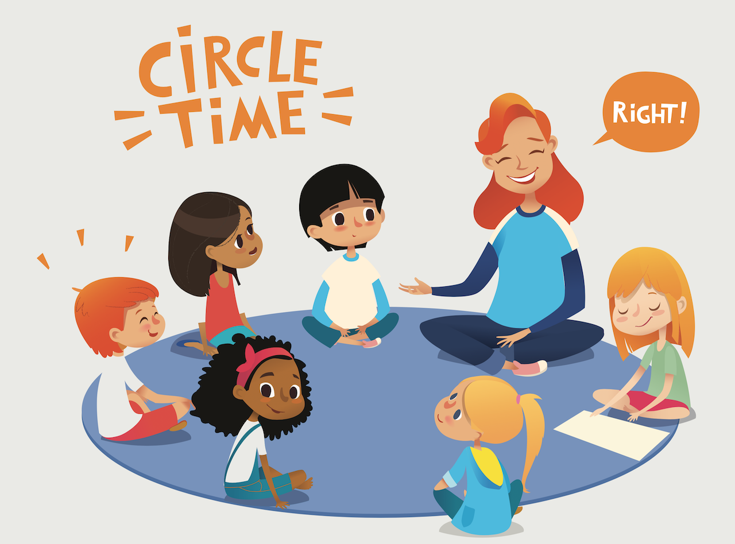
- I will be thinking about the sequence of events in ‘It’s a No-Money Day’ and talking about what happened at the beginning, middle and end.
- I will be learning to talk about how each character feels in the story.
- I will act out the story in my own words in the role-play area.
- I will be creating my own healthy shopping list.
- I will be talking about what foods are healthy and unhealthy.
- I will be learning to listen carefully to instructions on to make a rainbow skewer.

Personal Social Emotional Development (PSED)
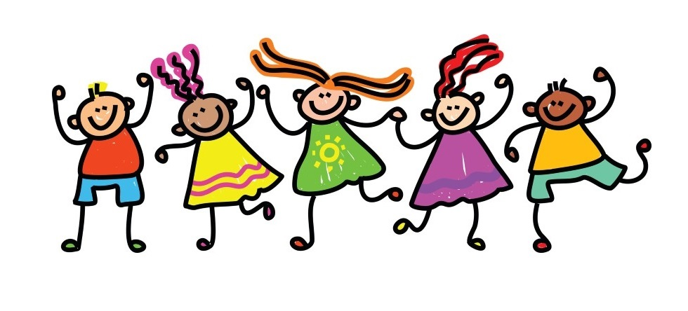
- I will be listening to the story ‘It’s a No-Money Day’ by Kate Milner and discussing how the characters felt throughout the story.
- I will be learning about the feelings of living in poverty and how I can help others who are visiting food banks.
- I will be learning about how some people don’t have enough food to eat to stay healthy. I will collect food for a local food bank.
- I will be finding out about people, communities and the world all around us, asking where our fruits and vegetables come from to get to our classroom or our plates.

Physical Development (PD)
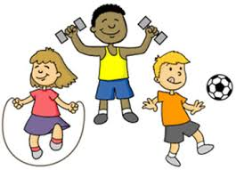
- I will be completing PE challenges.
- I will be learning how to dance to music.
- I will be learning how to complete an obstacle course using different parts of my body.
- I will be learning how to play football.
- I will learn what happens to my body when I do exercise.
- I will learn about the benefits of exercise to the mind and body.
- I will be doing a cereal threading activity to strengthen my hands.

“How can we keep ourselves healthy?”
Reception Topic Map Summer 2 2021

Understanding the World (UW)
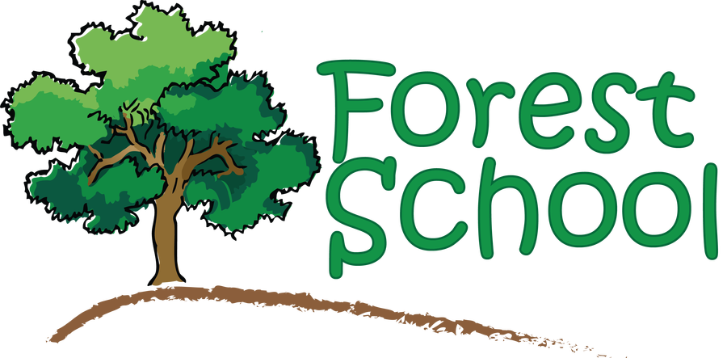
- I will be learning about healthy and unhealthy food.
- I will sort and classify food into healthy and unhealthy.
- I will be learning about different food groups and creating a balanced plate.
- I will be learning about teeth and how to look after our teeth.
- I will be learning about the famous nurse Florence Nightingale.
- I will be learning about Shabbat.
- I will be learning to empathise with Jewish children by understanding what they do during Shabbat and why it is important to them.

Expressive Arts & Design (EAD)
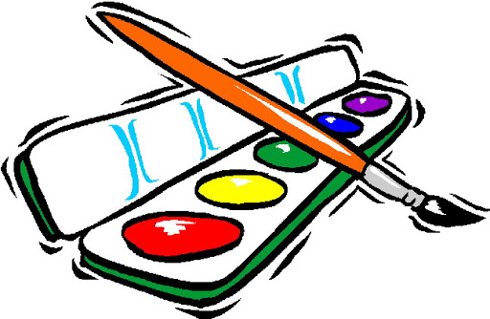
- I will be looking at the work of artist, Giuseppe Arcimboldo. I will look at some of the portraits made using food and use fruits and vegetables to create my own faces. I will use a camera to take a photo of my finished creation.
- I will be learning to do some observational drawings of the different fruits. I will use chalk to explore mixing colours together, by smudging them with my finger. This will create some lovely effects and shades of colour on the fruit.
- I will be learning to make model vegetables using playdough and clay.
- I will use a selection of dried peas or beans to make shakers. I will explore the sounds made by different contents.

Mathematics (M)
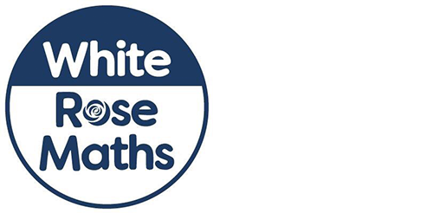
Using the White Rose Maths scheme:
- I will be learning about patterns.
- I will be making simple patterns.
- I will be learning odd and even numbers.
- I will be ordering numbers 0 – 20.
- I will be learning to add two numbers together.
- I will be learning to take away.
- I will be learning to double and halve.

Literacy (L)
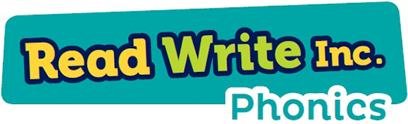
- Using the Read Write Inc. Phonics scheme:
- I will recap all previously taught sounds.
- I will be learning my Set 2 and starting set 3 Speed Sounds: air ir ou oy ea oi a-e.
- I will draw and label different fruits and vegetables.
- I will invent the next scene for ‘It’s a No-Money Day’ by Kate Milner. I will draw and write captions.
- I will look at some fruits and vegetables and think of adjectives to describe each of them. I will write a list of describing words, describing how they look, feel, smell and taste.

