STEETON PRIMARY SCHOOL
Market Street, Steeton, Keighley, West Yorkshire, BD206NN
Telephone: 01535 653315
Email:office@steeton.bradford.sch.uk
Website: www.steeton.bradford.sch.uk

Executive Head teacher: Mr. J. Cooper
Head of School: Mr. K. Wheeler

Friday 24th June 2022
Newsletter 33

Dear Parents and Carers

After 12 years at Steeton Primary, with the last 5 as Head of School, as you will now know from the letter sent out yesterday, I will be moving to Myrtle Park to take on the Head of School role in our new partner school. Whilst this new position is both exciting and a fresh challenge, leaving Steeton Primary was always going to be huge wrench after the journey we have been on. I especially appreciate the wonderful support I have been given by parents during my time here. However, this now feels so much easier knowing that the school is going to be in familiar capable hands with Ms Redman and Mrs Birtwistle.
I am looking forward to enjoying and sharing the last 4 weeks of term with you and your children around school.

Billy Bantam Penalty Shootout

Next Thursday, the 30th of June, please can you send in your child’s sponsor form only (not money) so Billy Can sign it to say that the penalties have been taken. We will then return it with your child so they can collect the monies and send that in after the event.

Transition Arrangements
The transition days for Years R to 5 will take place from Friday 15th to Tuesday 19th July. The children will spend time with their new teacher and class, getting to know each other and daily routines. On Tuesday 19^{th,} Parents are invited to drop in from 2:30pm to meet your child’s new class teacher.

Sports Day

I am still waiting final confirmation that the Sports Days will take place as advertised. I will ping out next week once I have received it.

Sports Events

Well done to all our children who took part in Yesterdays Mini Olympics at South Craven. Our athletes were: Ibrahim Iqbal, Hollie Sagar, Hamim Imaan, Nathaniel McLaren, Avaaya Shaw, Logan Cann, Azan Hussain, Annabel Coope, Austin Hamberley, Alex Wilkiewicz, Anna Graham, Arthur Prosser- Jackson, Kyle Dixon, Florence Drake, Johnan Shann, Mohammad Deen Hussain.

Ice Lollies
Ice lollies will continue to be sold at the end of school on a Friday. All monies collected will be shared amongst the classes to provide resources for the children.

Upcoming Events
There will be lots of events taking place during what is often our busiest half-term. Class Teachers will inform you of visits and visitors by Ping and events are on the school website.

Second-Hand Uniform Shop- Volunteer Appeal
We have now doubled our volunteers to 2! But we still need a few more to make sure this can run successfully from September. Please, if you can help in anyway get in touch with school.
We are now looking to run the shop in the school Library, Monday, Wednesday and Friday between 8:30am and 9:00am, so if you can spare this time as you drop off your children that would be ideal. We will also need some help with the setting up and preparation sessions in the next 5 weeks. This is so we can offer good quality, donated second hand uniform to all parents for a minimal donation.
We would be quite happy to have teams of parents on a rota system.
If you could help in anyway, please contact Mrs Kennedy for further details.

Steeton Superstars This Week
Well done to all the following:

Seedlings: George Hawker Christo Joshy
Saplings: Aizah Kamran Nuh Raj

Plum: Mustafa Deen Edwin Dony
Maple: Avaaya Shaw Hafsah Shakeel
Willow: Evaniya Sijo Florence Drake

Elder: Joseph Walmsley Safiya Javaid
Fir: Hooriya Hussain Ismael Hussain
Rowan: Mina Latif Amira Zain

Ash: Adam Ellahi Reuben Tillotson
Holly: Taylor Boraine Adam Sarwar
Silver Birch: Yassar Dad Yahya Waheed

Train to Teach at Steeton Primary.
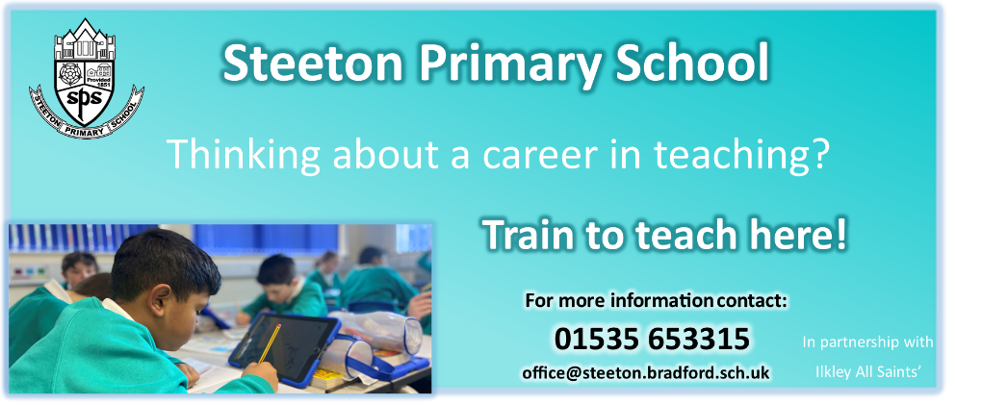
If you would like to train to teach at Steeton Primary School, please contact Mrs Birtwistle at school for further details.

In Term Holiday Requests

As stated on the Bradford Schools Online website “Parents should not take their children out of school without first seeking the school’s permission. Families do not have a right to take their children out of school for the purposes of family holidays or trips abroad. Parents should always speak to the school prior to any absence to discuss any information that they feel should be taken into consideration by the Headteacher in deciding whether to authorise the absence.”

The DfE guidance instructs Headteachers NOT to authorise leave of absence in term time. Permission for this type of absence should only be granted in the most exceptional circumstance.

If you are requesting to take your child out of school during term time, please email Mrs Kennedy at sharmyn.kennedy@steeton.bradford.sch.uk, at least 2 weeks prior to your date of departure.
She will send you all the relevant information.

Lost Property

With the weather getting warmer, we now have an array of lost property. This will be put outside near the main gate every Monday morning. If your child has lost an item, please come and check. Usually, if your child's name is in or on their item, it will be returned to them
Traffic

The Council Wardens have asked me to pass on to parents that they will continue to make random visits at the beginning and end of the school day. They said they will continue to ticket drivers who stop on the zig zags to pick up or drop off passengers and any other parking offences they see.

Car Parking in locality
Please continue to park and drive carefully and legally around school and the surrounding roads for the safety of the whole school community and local residents.
Just a reminder that the car park by the main school gate is for staff only. This is coned off in the afternoon. Please do not stand within this coned off area or allow children to play/enter the carpark.
I thank you for future cooperation in this matter.
Free School Meals

If you claim Income Support, Universal Credit or have are on a low income, your child may be eligible for Free School Meals.

Benefits include:
- Free school meals for your child regardless of what year they are in
- Subsidised or free school trips
- Vouchers towards the costs of school uniform
- Free school milk
- Free music lessons within school
- A grant for school for activities and resources
Applying is easy and all online. You do not need to send in any documentation. All you need is your address, National Insurance number and dates of birth for people living in your house hold. You will receive an instant response.
You can apply through Mrs Kennedy, who can complete the application with you either over the phone or in person.
OR
You can apply yourself using an online form. Go to: www.bradford.gov.uk/benefits/applying-for-benefits/free-school-meals
If you think you might be eligible, please speak to Mrs Kennedy, who can help you apply and give you further information.

People who suffer from nut allergies can develop a severe, potentially life-threatening allergic reaction. We have a number of children to who this applies.
If someone has a nut allergy it is not just eating nuts that can cause a severe reaction, just being touched on the skin or smelling the breath of someone who has had nuts or a product containing nuts can trigger anaphylactic shock (which can cause breathing and swallowing difficulties).
We cannot have nuts in school in any form. So please can we ask that you have no nut products in the lunch boxes.

For example
- Peanut butter sandwiches
- Chocolate spreads
- Some cereal bars
- Some granola bars
- Cakes that contain nuts
- Biscuits / Cookies that contain nuts
- Peanut butter cakes
- Food with Satay Sauces.
This list is not exhaustive, so please check the packaging of products closely.
I know if this was your child, you would expect that we all help, especially as it is a life-threatening condition.
If you have any questions, please do not hesitate to speak to a member of staff.

