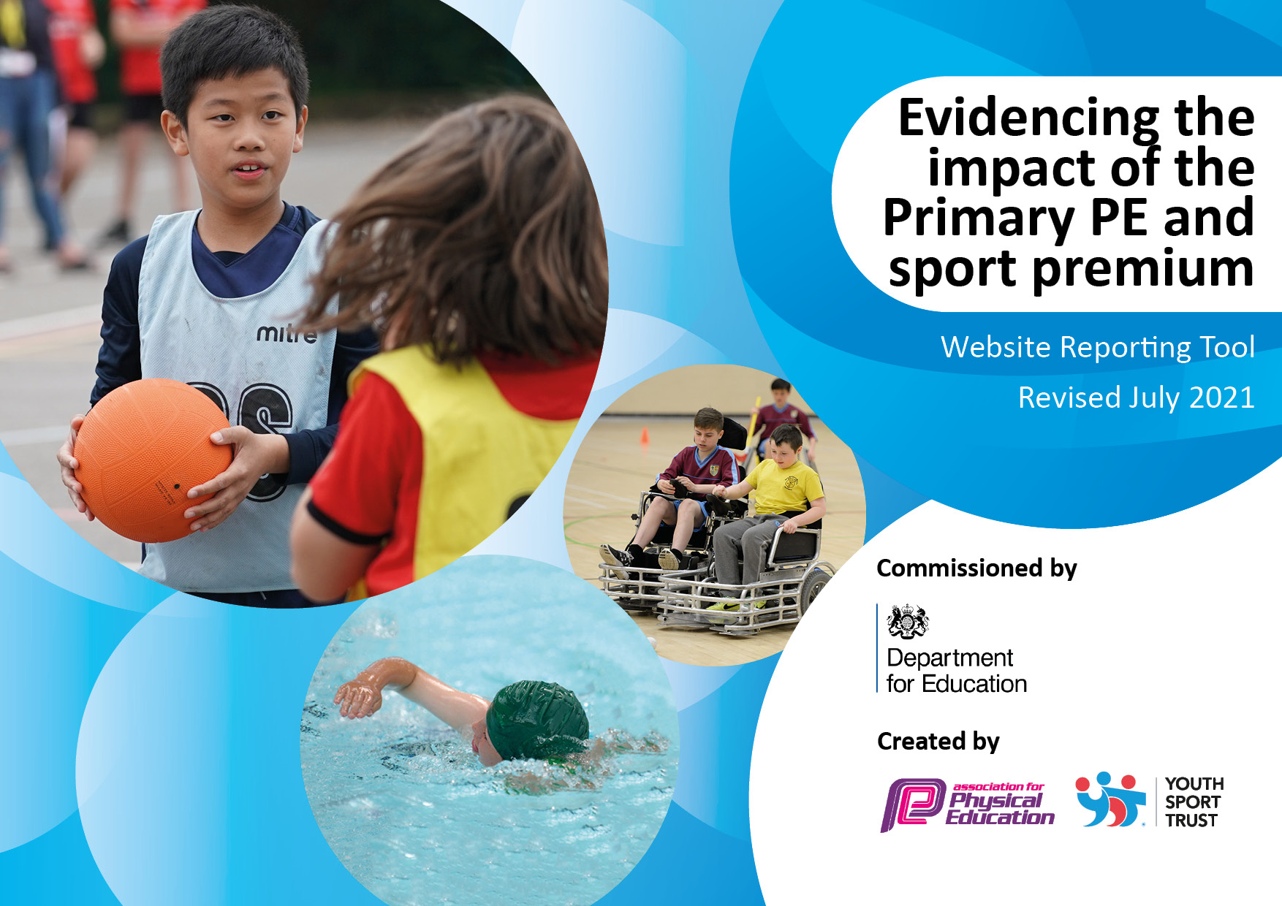
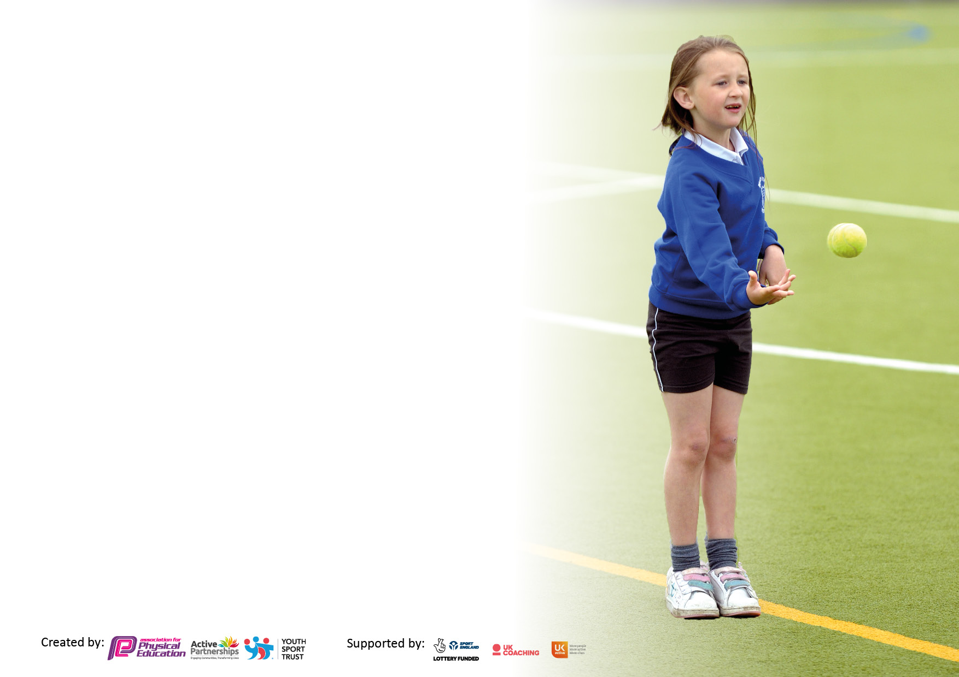

It is important that your grant is used effectively and based on school need. The Education Inspection Framework makes clear there will be a focus on ‘whether leaders and those responsible for governors all understand their respective roles and perform these in a way that enhances the effectiveness of the school’.

Under the Quality of Education Ofsted inspectors consider:
Intent - Curriculum design, coverage and appropriateness
Implementation - Curriculum delivery, Teaching (pedagogy) and Assessment
Impact - Attainment and progress

To assist schools with common transferable language this template has been developed to utilise the same three headings which should make your plans easily transferable between working documents.

Schools must use the funding to make additional and sustainable improvements to the quality of Physical Education, School Sport and Physical Activity (PESSPA) they offer. This means that you should use the Primary PE and sport premium to:

- Develop or add to the PESSPA activities that your school already offer
- Build capacity and capability within the school to ensure that improvements made now will benefit pupils joining the school in future years
- The Primary PE and sport premium should not be used to fund capital spend projects; the school’s budget should fund these.

Pleasevisitgov.ukfortherevisedDfEguidanceincludingthe5keyindicatorsacrosswhichschoolsshoulddemonstrate animprovement.Thisdocumentwillhelpyoutoreviewyourprovisionandtoreportyourspend.DfEencouragesschools to use this template as an effective way of meeting the reporting requirements of the Primary PE and sport premium.

We recommend you start by reflecting on the impact of current provision and reviewing the previous spend.

Schools are required to publish details of how they spend this funding, including any under-spend from 2021/2022, as well as on the impact it has on pupils’ PE and sport participation and attainment. All funding must be spent by 31st July 2023.

We recommend regularly updating the table and publishing it on your website throughout the year. This evidences your ongoing self-evaluation of how you are using the funding to secure maximum, sustainable impact. Final copy must be posted on your website by the end of the academic year and no later than the 31st July 2023. To see an example of how to complete the table please click HERE.
Created by: Supported by:

Details with regard to funding
Please complete the table below.

Total amount allocated for 2021/22 | £18,460
How much (if any) do you intend to carry over from this total fund into 2022/23? | £0
Total amount allocated for 2022/23 | £18,478
Total amount of funding for 2022/23. To be spent and reported on by 31st July 2023. | £18,478
Swimming Data
Please report on your Swimming Data below.

Meeting national curriculum requirements for swimming and water safety.

N.B. Complete this section to your best ability. For example you might have practised safe self-rescue techniques on dry land which you can then transfer to the pool when school swimming restarts.
Due to exceptional circumstances priority should be given to ensuring that pupils can perform safe self rescue even if they do not fully meet the first two requirements of the NC programme of study
What percentage of your current Year 6 cohort swim competently, confidently and proficiently over a distance of at least 25 metres?  N.B. Even though your pupils may swim in another year please report on their attainment on leaving primary school at the end of the summer term 2021.  Please see note above | 20%
What percentage of your current Year 6 cohort use a range of strokes effectively [for example, front crawl, backstroke and breaststroke]?  Please see note above | 20%
What percentage of your current Year 6 cohort perform safe self-rescue in different water-based situations? | 20%
Schools can choose to use the Primary PE and sport premium to provide additional provision for swimming but this must be for activity over and above the national curriculum requirements. Have you used it in this way? | No

Action Plan and Budget Tracking
Capture your intended annual spend against the 5 key indicators. Clarify the success criteria and evidence of impact that you intend to measure to evaluate for pupils today and for the future.

Academic Year: 2022/23 | Total fund allocated: £18478 | Date Updated: July2023
Key indicator 1: The engagement of all pupils in regular physical activity – Chief Medical Officers guidelines recommend that primary school pupils undertake at least 30 minutes of physical activity a day in school |  |  |  | Percentage of total allocation:
 |  |  |  | 19%
Intent | Implementation |  | Impact
Your school focus should be clear what you want the pupils to know and be able to do and about  what they need to learn and to  consolidate through practice: | - Make sure your actions to achieve are linked to your intentions: | Funding allocated: | - Evidence of impact: what do pupils now know and what can they now do? What has changed?: | - Sustainability and suggested next steps:
Intended impact:  At Steeton, we want our children to be both mentally and physically engaged throughout their time at school, both within the PE provision and in the rich extra-curricular provision we offer. We want all children to be given the opportunity to develop physically through a diverse range of after school sports clubs, intra and interschool competitions. | - Employ 1 x Sports Lead at lunchtime in KS2 to engage children in multi skills activities for a period of 38 weeks | £ 3533.00 | - Pupils games skills have improved over the course of the year. This includes an increase in their resilience in terms of losing and sticking at a sport when it starts to become difficult.  - Pupils behaviour and attitudes within the playground are good or better.  - Children have been more physically active throughout lunchtimes and have learned to cooperate more readily with each other through teamwork and better communication. | - This is an activity that with sustained funding school leaders would lie to continue.  - New school leaders would like to develop our intra school participation in sports after school.
Key indicator 2: The profile of PESSPA being raised across the school as a tool for whole school improvement |  |  |  | Percentage of total allocation:
 |  |  |  | 36%
Intent | Implementation |  | Impact
Your school focus should be clear what you want the pupils to know and be able to do and about  what they need to learn and to  consolidate through practice: | - Make sure your actions to achieve are linked to your intentions: | Funding allocated: | - Evidence of impact: what do pupils now know and what can they now do? What has changed? | Sustainability and suggested next steps:
At Steeton we ensure that Physical education is the planned, progressive learning that takes place in the school’s curriculum timetabled time. It is delivered to all pupils.  This involves both ‘learning to move’ (i.e. becoming more physically competent) and ‘moving to learn’ (e.g. learning through movement, a range of skills and understandings beyond physical activity, such as co-operating with others). The context for the learning is physical activity, with children experiencing a broad range of activities, including sport and dance.  At Steeton we see physical activity is a broad term referring to all bodily movement that uses energy. It includes all forms of physical education, sports and dance activities. However, it is wider than this, as it also includes indoor and outdoor play, work-related activity, outdoor and adventurous activities, active travel (e.g. walking, cycling, rollerblading, scooting) and routine, habitual activities such as using the stairs, doing housework and gardening. | - Provide opportunities throughout the ‘Learning for Life’ curriculum for children to use movement as a tool for their learning.  - Using the established Forest School provide funding for a Forest School Leader to allow each class to have a day each half term in the forest school in order to put Physical Education, School Sport and Physical Activity at the heart of our curriculum. | £ 6,600.00 | - Pupils have had the opportunity to use movement more widely outdoors linking the outdoors to our richly creative curriculum. | - Moving forward we will continue to use the Sports Premium funding to fund a Forest School Teacher so that each class has at least 1 Forest school day every half term.

Key indicator 3: Increased confidence, knowledge and skills of all staff in teaching PE and sport |  |  |  | Percentage of total allocation:
 |  |  |  | 22%
Intent | Implementation |  | Impact
Your school focus should be clear | Make sure your actions to | Funding | Evidence of impact: what do | Sustainability and suggested
what you want the pupils to know | achieve are linked to your | allocated: | pupils now know and what | next steps:
and be able to do and about | intentions: |  | can they now do? What has
what they need to learn and to |  |  | changed?:
consolidate through practice:
At Steeton our intent is to ensure that Physical education is planned, progressive learning. To enable this to happen we have engaged a professional HLTA sports coach to coordinate sports provision across school. | - Provide a grant toward the HLTA sports coach to coordinate excellent sporting provision across school. | £4145 | - Pupils have experienced quality coaching over a range of sporting activity that they would not normally have been able to access.  - There sporting skills across these sports have improved  - Staff also taking part have improved their confidence and expertise resulting in improved Physical Education a Steeton.  - PE lessons are fun and enjoyable, children are engaged and look forward to developing themselves physically. PE forms a backbone for being an active school and our pupils understand how to lead a healthy, active lifestyle and understand the importance of exercising regularly on their both their mental and physical wellbeing | - Sporting opportunities and activities pervade school life.  - School leaders intend to retain this funding and highly successful model.
Key indicator 4: Broader experience of a range of sports and activities offered to all pupils |  |  |  | Percentage of total allocation:
 |  |  |  | N/A
Intent | Implementation |  | Impact
Your school focus should be clear | Make sure your actions to | Funding | Evidence of impact: what do | Sustainability and suggested
what you want the pupils to know | achieve are linked to your | allocated: | pupils now know and what | next steps:
and be able to do and about | intentions: |  | can they now do? What has
what they need to learn and to |  |  | changed?:
consolidate through practice:
At Steeton, we want our children to be both mentally and physically engaged throughout their time at school, both within the PE provision and in the rich extra-curricular provision we offer. We want all children to be given the opportunity to develop physically through a diverse range of after school sports clubs, intra and interschool competitions. | - Please see indicator 1 & 3 for evidence of the broadening of children’s experience and range of sports on offer due to the Sports Premium Grant. | As above | - PE lessons are fun and enjoyable, children are engaged and look forward to developing themselves physically. PE forms a backbone for being an active school and our pupils understand how to lead a healthy, active lifestyle and understand the importance of exercising regularly on their both their mental and physical wellbeing | - We would wish to continue with the above activities as described

Key indicator 5: Increased participation in competitive sport |  |  |  | Percentage of total allocation:
 |  |  |  | 23%
Intent | Implementation |  | Impact
Your school focus should be clear | Make sure your actions to | Funding | Evidence of impact: what do | Sustainability and suggested
what you want the pupils to know | achieve are linked to your | allocated: | pupils now know and what | next steps:
and be able to do and about | intentions: |  | can they now do? What has
what they need to learn and to |  |  | changed?:
consolidate through practice:
At Steeton we want the children to have many opportunities to compete in both intra and inter school competitions throughout their time at Steeton Primary School. A ‘School Games’/Sports day occurs in the final week of the academic year, which all children participate in, within their year groups. Year 6 children are given the opportunity to train and become Play Leaders which allows them to further develop their leadership skills before moving on to secondary school. | - Provide transport and entrance fees to external and intra schools sports competitions  - Provide equipment and medals to stage in school games competitions and sports days.  - Provide time out/backfill for HLTA Sports coach to take children to sporting activities. | £800.00  £400.00  £3000.00 | - Children have been able to see and learn good practice across a range of sports throughout the year. The competitions and sports day have enabled them to see them as real-life events that they can take part and enjoy. | - This is an element of sports funding that we would want to continue and expand.  - School leaders would like to develop our intra school participation in sports after school.

Signed off by
Head Teacher: | Miss Claire Redman
Date: | Thursday, 20 July 2023
Subject Leader: | Kaleb Shaw
Date: | Thursday, 20 July 2023
Governor: | Emma Wainwright
Date: | Thursday, 20 July 2023

