# Pupil premium strategy statement

This statement details our school’s use of pupil premium (and recovery premium for the 2024 to 2025 academic year) funding to help improve the attainment of our disadvantaged pupils.

It outlines our pupil premium strategy, how we intend to spend the funding in this academic year and the effect that last year’s spending of pupil premium had within our school.

**School overview**

|  |  |
| --- | --- |
| **Detail** | **Data** |
| School name | Steeton Primary School |
| Number of pupils in school | 274 |
| Proportion (%) of pupil premium eligible pupils | 25.55% |
| Academic year/years that our current pupil premium strategy plan covers **(3-year plans are recommended)** | 2024-27 |
| Date this statement was published | October 2024 |
| Date on which it will be reviewed | Summer 2025 |
| Statement authorised by | John Cooper |
| Pupil premium lead | Claire Redman |
| Governor / Trustee lead | Sue West |

**Funding overview**

|  |  |
| --- | --- |
| **Detail** | **Amount** |
| Pupil premium funding allocation this academic year | **£85,368** |
| Recovery premium funding allocation this academic year | £0.00 |
| Pupil premium funding carried forward from previous years (enter £0 if not applicable) | £0 |
| **Total budget for this academic year**  If your school is an academy in a trust that pools this funding, state the amount available to your school this academic year | **£85,368** |

# Part A: Pupil premium strategy plan

## Statement of intent

***We want our pupil premium children to be at the heart of our Vision and Ethos at Steeton Primary School:***

***‘Your Inspirational Community.’***

* Our strategy intends to be inclusive giving our Pupil Premium children and families ownership and partnership within *their* school.
* We offer inspiration for all our pupils but none more so than our most disadvantaged. All teaching and learning systems within school are designed to provide the best educational experience for all children. Pupil Premium children are at the front of the queue when monitoring their effectiveness. We recognise that disadvantaged children experience a significant deficit of ‘‘Cultural Capital’1 in their lives. Our aim is to identify all children’s development points in this area. We do this by providing a rich and diverse curriculum with a heavy emphasis on creativity. Art/Craft and Design, encapsulated in schools hugely successful ‘Magic Mondays’2 provides a springboard for children to gain an appreciation and taste for human creativity and achievement. Steeton Primary School offers a highly effective dual approach to learning. Each child needs the skills across the whole curriculum to create exquisite ‘Learning for Life’ logs; focusing on honing their creative skills rather than rely on printed materials. Equally important to children is the access to state-of-the-art Information technology tools which we have meticulously planned into the whole curriculum to enable children to easily and efficiently complete fluency tasks which have, in the past, taken up so much learning time. Technology and Creativity working effortlessly together. This is what we have invested in as this is what our children need. Again, none more so than for our Pupil Premium children.
* We offer a community to all our pupils that makes them feel special and looked after in many ways. We need our children to think about the world and life beyond primary school. We have invested time and resources to enable them to do that and provide a summary of that strategy below.

1Cultural Capital: ‘It is the essential knowledge that pupils need to be educated citizens, introducing them to the best that has been thought and said and helping to engender an appreciation of human creativity and achievement. Ofsted Education Inspection Framework

2 ‘Magic Mondays’: Part of the school’s creative curriculum, a day each week devoted to the creative skills of Art/Craft & Design linked to curriculum themes producing age related products and outcomes across the school.

This details the key challenges to achievement that we have identified among our disadvantaged pupils.

|  |  |
| --- | --- |
| **Challenge number** | **Detail of challenge** |
| 1 | To arrest and reverse the significant deficit of ‘‘Cultural Capital’ in the lives of our most disadvantaged pupils. |
| 2 | To mitigate against children’s lack of experiences in the home environment. |
| 3 | To mitigate against digital poverty |
| 4 | Steeton is an accredited reading school. The challenge is to maintain high levels of engagement not only within school but within children’s homes and communities. Particular focus will be on those children living in the most deprived areas, ensuring they have equity of access. |
| 5 | To provide targeted support to children who still suffer a disproportional educational impact as a result of lockdowns in 2020-2021. We recognise that this continues to be felt in families with the highest levels of depravation. |

## Intended outcomes

This explains the outcomes we are aiming for **by the end of our current strategy plan**, and how we will measure whether they have been achieved.

|  |  |
| --- | --- |
| **Intended outcome** | **Success criteria** |
| Targeted support for pupil premium children will raise attainment for pupil premium children. | * Raise the whole school attainment for Pupil Premium children to those levels seen by all other children * Close the attainment gap in specific year groups which were reported to have the lowest level of pupil premium achievement |
| Build upon the Cultural Capital of all our Pupil Premium children. | * All PP children will go on school visits free of charge. * At least 75% of PP children to take part in at least one after school clubs free of charge. |
| Pupil Premium children develop a pride in their creative and academic skills across the curriculum | * Learning for Life logs of Pupil premium children show rapid progression of skills and are regularly monitored. * Individual mentoring time provided for each child. |

## Activity in this academic year

These activities detail how we intend to spend our pupil premium (and recovery premium funding)

**this academic year** to address the challenges listed above.

### Teaching (for example, CPD, recruitment and retention)

Budgeted cost: **£58,000.00**

|  |  |  |
| --- | --- | --- |
| **Activity** | **Evidence that supports this approach** | **Challenge number(s) addressed** |
| Additional teaching  assistant time to  support creativity in the curriculum | * There is a wealth of evidence which points to the squeezing of Art/ Design within a richly creative curriculum correlates to a decline in motivation, engagement and standards for our most disadvantaged pupils. * Schools own data shows that when Phonics provision is delivered by sufficient well-trained TAs that can provide a range of groupings to provide SSP5 | 1-4 |
|  |
|  |
|  |
| Additional teaching  assistant time to  support the teaching of Phonics |  |
| 4 |
|  |
| CPD in technology:  Addressing digital poverty in school; ensuring equal access for all | * When children access state of the art Information technology tools which we have meticulously planned into the whole curriculum, it enables children to easily and efficiently complete fluency tasks which have, in the past, taken up so much learning time. * National Education Union 2022: ‘Digital poverty continues to widen the education gap, with many primary children form disadvantaged communities still struggling without adequate devices or internet access, hindering their ability to keep pace with their peers post-pandemic.’ | 3&5 |
| CPD for all staff in reading and children’s trips, visits and visitors, such as bookshops, libraries and authors | * Professor Teresa Cremin 2019 says, ‘Children who read for pleasure improve their life chances not just academically but in relation to their well-being and relationships.’ * In surveys, 65% of our children had never visited a book shop or library. * 22% of our staff could not name current and diverse children’s authors needed to provide literature as windows and mirrors for our children. | 2&4 |

5 SSP: Systematic synthetic phonics is **k**ey to teaching children reading and writing. It provides them with strategies to decode words

|  |  |  |
| --- | --- | --- |
| Provision of personnel for after school clubs accessible to all but directed towards having at least 75% of PP children taking part. | * See above for art/craft/design clubs. * A high-quality physical education curriculum inspires all pupils to succeed and excel in competitive sport and other physically-de- manding activities. It should provide opportunities for pupils to become physically confident in a way which supports their health and fitness. Opportunities to compete in sport and other activities build character and help to embed values such as fairness and respect.8 | 1  5 |
| Provision of Inclusion & Welfare Officer to safeguard all children, with a significant proportion of PP children receiving direct support. | * There were two in five children aged under 15 living in relative poverty in Bradford in 2023 according to Bradford’s Anti-Poverty Strategy 2022-27. * The need for a funded Inclusion and Welfare Officer in every primary school has never been greater. | 1-5 |

### Targeted academic support (for example, tutoring, one-to-one support structured interventions)

Budgeted cost: £ ***6,000.00***

|  |  |  |
| --- | --- | --- |
| **Activity** | **Evidence that supports this approach** | **Challenge number(s) addressed** |
| Provide targeted support for Pupil Premium Children as identified in Pupil progress meetings. | * Primary-aged pupils have experienced a learning loss in reading and mathematics. This was typically equivalent to between 2.0 and 2.3 months of progress in reading, and between 3.1 and 3.6   months in mathematics. There was | 5 |

|  |  |  |
| --- | --- | --- |
|  | further learning loss in primary schools in England, particularly in reading, following restrictions to in- person learning in early 2021.10   * Pupils from disadvantaged backgrounds experienced higher levels of loss than their non- disadvantaged peers (1 month more learning loss in reading and 0.5 months more in mathematics compared to their non- disadvantaged peers). The effect on disadvantaged pupils is equivalent to undoing a third of the progress made in the last decade on closing the gap in primary schools. * EEF: Evidence indicates that one to one tuition can be effective, provid- ing approximately five additional   months’ progress on average.12 |  |

### Wider strategies (for example, related to attendance, behaviour, wellbeing)

Budgeted cost: **£2779.00**

|  |  |  |
| --- | --- | --- |
| **Activity** | **Evidence that supports this approach** | **Challenge number(s) addressed** |
| Grant toward provision of free educational visits and residential visits for ‘Ever 6 FSM’ children. | * We recognise that disadvantaged children experience a significant deficit of ‘‘Cultural Capital’13 in their lives. Our aim is to identify all children’s development points in this area. We do this by providing a rich and diverse   curriculum with a heavy | 1 & 2 |

10 Best evidence on impact of Covid-19 on pupil attainment Research examining the potential impact of school closures on the attainment gap EEF: https://sandbox.educationendowmentfoundation.org.uk/guidance-for-teachers/covid-19-resources/best- evidence-on-impact-of-covid-19-on-pupil-attainment

13Cultural Capital: ‘It is the essential knowledge that pupils need to be educated citizens, introducing them to the best that has been thought and said and helping to engender an appreciation of human creativity and achievement. Ofsted Education

Inspection Framework

|  |  |  |
| --- | --- | --- |
|  | emphasis on creativity. Art/Craft and Design   * There were **4.3 million children** liv- ing in poverty in the UK in 2019-20. That's 31 per cent of children,   or **nine in a classroom of 30**.14 |  |
| *Provide a grant for each key stage to provide the resources for a Creative Curriculum which will work towards closing the Gap culturally and academically between children who are socially disadvantaged and those who are not.* | * The need for children to be able to explore their creative heritage is urgent and pressing to close the cultural and attainment gap that some families face. (see above) | 1 & 2 |

### Total budgeted cost: £ 85,368

14 Households Below Average Income, Statistics on the number and percentage of people living in low income households for financial years 1994/95 to 2019/20, Table 4.3tr. **Department for Work and Pensions, 2021**

# Part B: Review of outcomes in the previous academic year

**Pupil Premium Performance 2024**

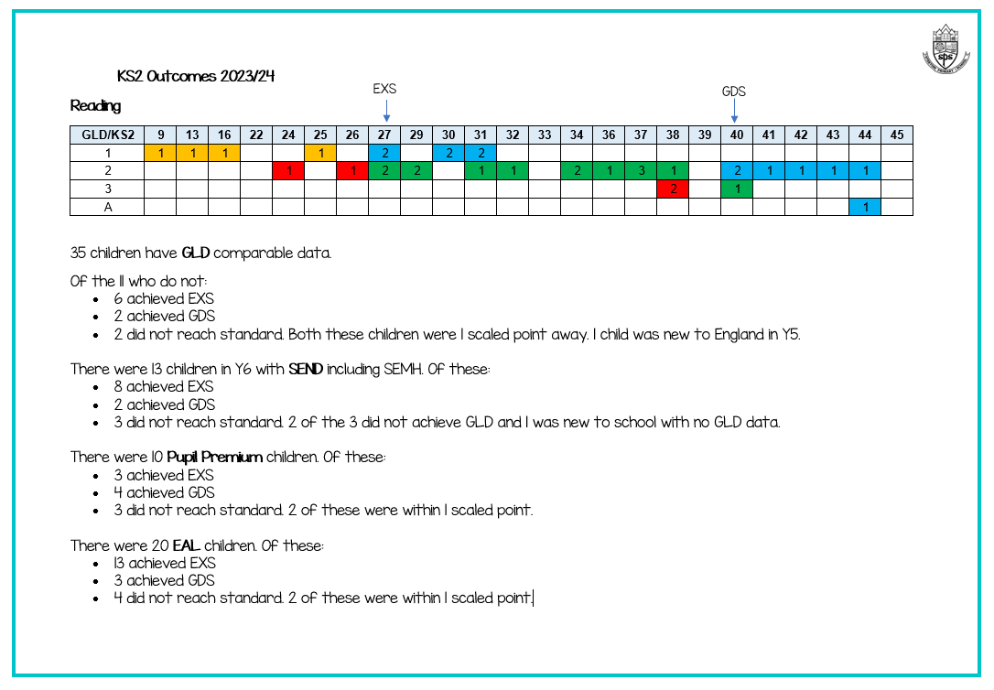

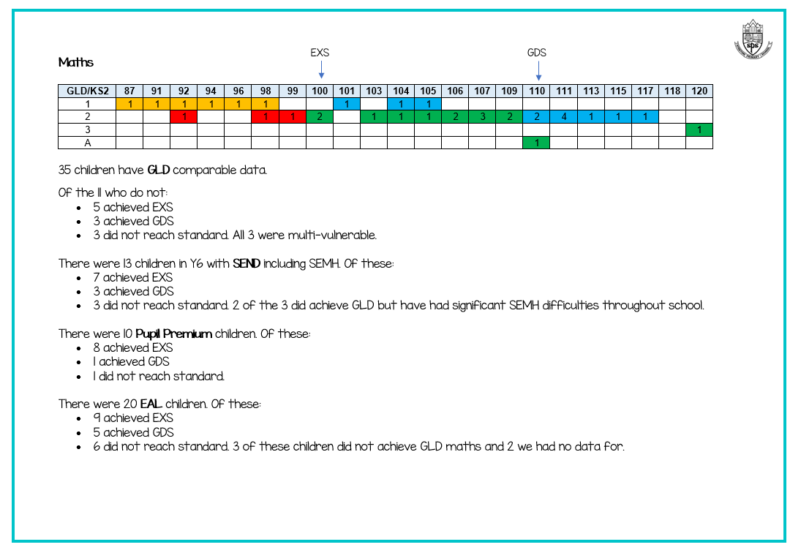

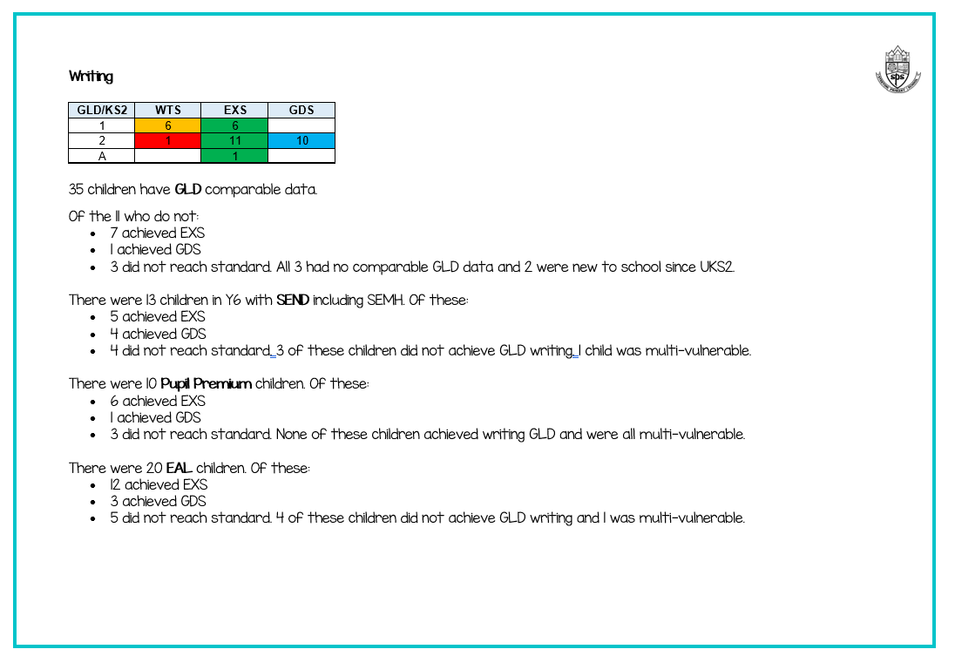

**Further information (optional)**

*Use this space to provide any further information about your pupil premium strategy. For example, about your strategy planning, or other activity that you are implementing to support disadvantaged pupils, that is not dependent on pupil premium or recovery premium funding.*